# **CHAPTER 03**

# **MATERIALS AND METHODS**

## **3.1 Experimental Location**

The field experiment was carried out in open fields at the agronomy division of the Rice Research and Development Institute (RRDI), Bathalagoda (Longitude- 80.264 0, Latitude- 7.5310) in the Low country Intermediate Zone (IL1) of Sri Lanka. The experiment was conducted during the “Maha” season from September to December 2018. The annual rainfall of the area is 1500-2285mm and the daily mean temperature is 230C – 280C. The soil type of that area is Red Yellow Podzolic.

## **3.2 Description of the Treatments and Experimental Design**

The experiment for determination of optimum seed rate for nursery trays use for Machine Transplanting was conducted using the Complete Randomized Design (CRD) separately for the two varieties Bg 360 (three and half month’s variety with white short round shape, Keera Samba) and Bg 374 (three and half month’s variety with white intermediate bold shape, Nadu) in order to generalize the experiment. The experiment was consisting with four treatments and three replicates, which included with twelve experimental units for each variety. One nursery tray was considered as an experimental unit.

**Table 3.1 Treatment combinations**

|  |
| --- |
| 75g / tray  100g / tray  150g / tray  200g / tray  1  2  3  4  Treatment  Seed rate |

|  |
| --- |
|  |

As the design for the experiment, Comparison of mechanical transplanting with other establishment methods Randomized Complete Block Design (RCBD) was used separately for the two varieties Bg 360 and Bg 374. The experiment was conducted in two stages including the nursery period and period after field establishment to the end of vegetative phase in the field. The experimental design was consisting with three replicates and four treatments; therefore, twelve experimental units for one variety. One block was considered as one experimental unit and two fields were used separately for the two varieties.

**Table 3.2 Treatment combinations**

|  |
| --- |
| Broadcasting (BC)  Random Transplanting (RT)  Mechanical Transplanting (MT)  Parachute method (PA)  1  2  3  4  Treatment  Establishment method |
|  |

## **3.3 Agronomic Practices**

### **3.3.1 Nursery Management**

The first experiment was determination of optimum seed rate for nursery trays for that the raised beds were prepared in the field for about 5 cm height, width of 60 cm and the length of 360 cm separately for the two varieties. The trays (30*60cm) were arranged according to the experimental design and fine mud or fine textured soil without any pebbles was filled uniformly in to each tray up to 2.5cm thickness. The treatments were randomized and allocated to the trays accordingly and the trays were labelled according to the received treatment for identification (Figure 3.1). The seed samples of the two varieties Bg 360, Bg 374 which showed 90% germination percentage were selected. The seeds were distributed uniformly on the trays according to the seed rates allocated by each treatment after 24 hours soaking followed by 24 hours incubation period. The nursery beds were covered with coconut leaves for about 3 to 4 days, in order to avoid the damage from the high rain condition prevailed during that period and the damages from animals. Then the seedlings were hardened to the environment by exposing them to the sunlight during the morning period for some days and then the seedlings were fully exposed to the sunlight. The seedlings were raised for 12 days period and then uprooted for taking measurements.

R3T4

R1T3

R2T4

R1T1

R2T2

R1T4

R3T1

R1T2

R3T3

R2T3

R2T1

R3T2

Figure 3.1 Layout of Nursery tray experiment

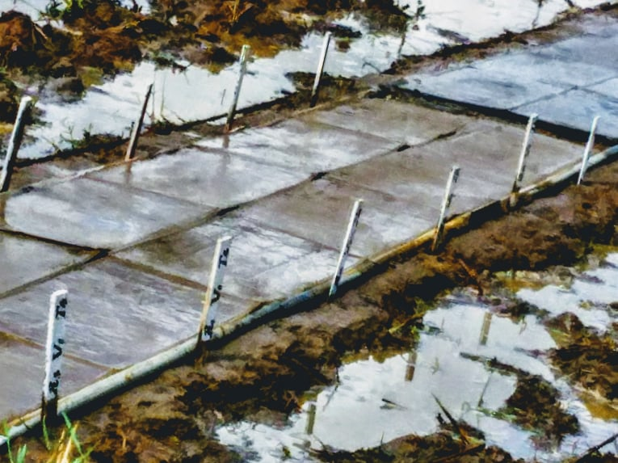

Plate 3.1 Arrangement of the nursery trays for the experiment

For the second experiment comparison of Mechanical Transplanting with other establishment methods, nurseries are prepared as Wet bed for Random Transplanting, Parachute nursery, nursery trays for Mechanical Transplanting and the Broadcasting was done. The nursery beds for the Wed bed, Parachute are prepared according to the seed rates recommended by the Department of Agriculture (DOA) Sri Lanka and for the nursery trays use for machine transplanting the optimum seed rate found from the first experiment was used. Raised beds are prepared and leveled well for wet beds as 1/10 of the area from the total area to be established. The seed rate was used as the recommendations which was 40 kg/ha for the variety Bg 360 and 50 kg/ha for the Bg 374. The germinated seeds were scattered uniformly on the nursery bed after 24 hours of water soaking followed by 48 hours of incubation. The raised beds were prepared for parachute trays (30*60 cm, with 434 plugs) with 10 cm height, width of 60 cm and the length was adjusted according to the number of trays required. The trays were kept on the raised beds and filled with fine mud up to the 2/3 height of the parachute trays. The seed rate use for the Parachute trays was 12 kg/acre for the both varieties Bg 360 and Bg 374. The germinated seeds after water soaked for 24 hours followed by incubation period of 24 hours, were distributed uniformly on the nursery trays as 3 seeds per each hole and covered with a thin layer of mud. The nursery trays (60*30 cm) were kept on levelled raised beds and the fine mud was filled up to the thickness of 2.5cm for the modified dapog nurseries use in mechanical transplanting. The seed rate used for Bg 360 was 100g per tray and the seed rate used for the variety Bg 374 was 150g per tray according to the results of the previous experiment. The germinated seeds were scattered uniformly on the trays after water soaked and incubated for 24 hours. The three nurseries were covered with coconut leaves from about 3 to 4 days period to prevent damages from high rain, animals’ ant to conserve the moisture. The hardening of the seedlings was done by gradually increasing the time period of seedlings exposing to the sunlight. The Direct sowing of seeds was done on the date of nursery establishment in order to get an even aged plants to get data for comparison of growth parameters.

### **3.3.2 Land Preparation**

The land preparation was done according to the recommendation of Department of Agriculture (DOA) Sri Lanka. After the basic land preparation practices the land was prepared according to the layout (Figure 3.2). The blocks were prepared with the dimensions of 7 m length and 4.5 m width, and 30cm space was kept between each block. The experiment was conducted in two fields for two varieties using the same layout.

R1,MT

R1, BC

R1, PA

R1, RT

R1,PA

R1, RT

R1, MT

R1, BC

R1,BC

R1, PA

R1, RT

R1, MT

Figure 3.2 Layout of the experiment field

### **3.3.3 Crop Establishment**

### **3.3.4 Management Practices**

#### **3.3.4.1 Fertilizer Application**

#### **3.3.4.2 Weed control, Pest and Disease Control**